1. **To implement connection between devices using a router.**

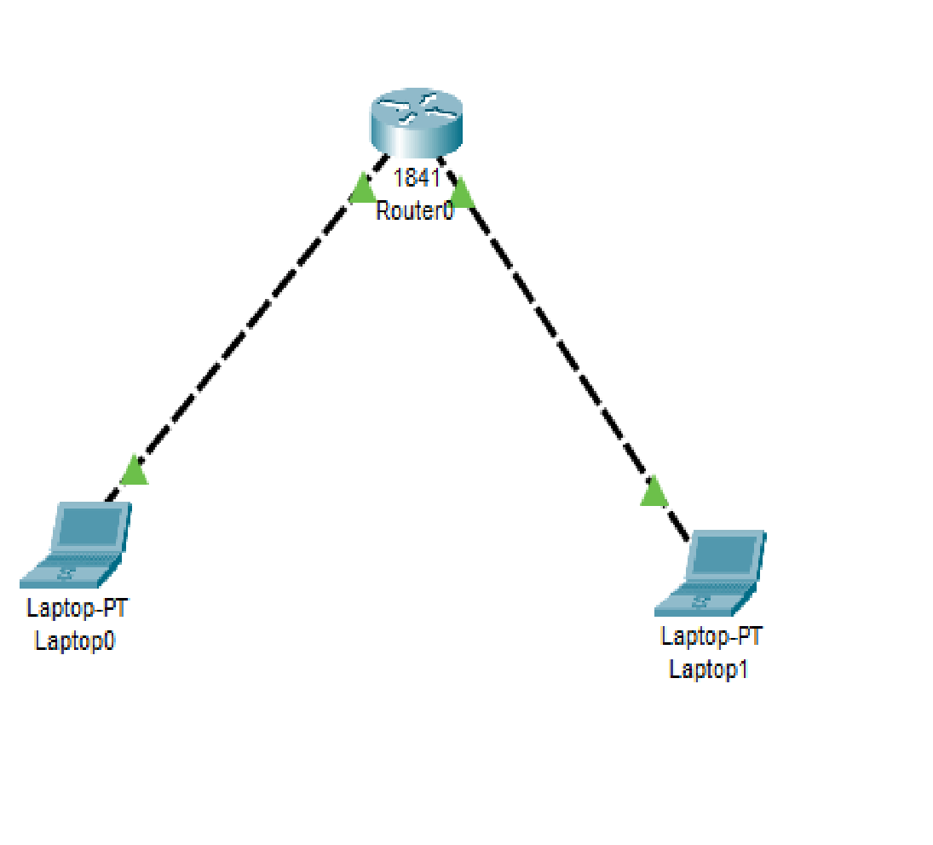

## Laptop 0

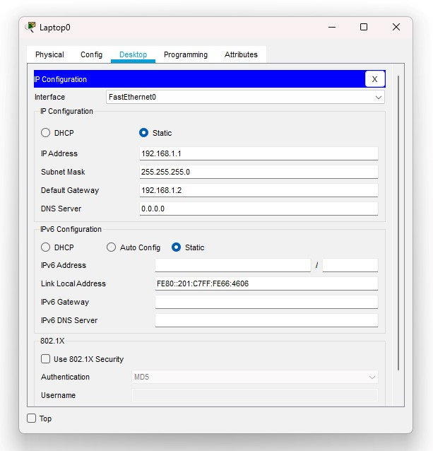

## Laptop 1

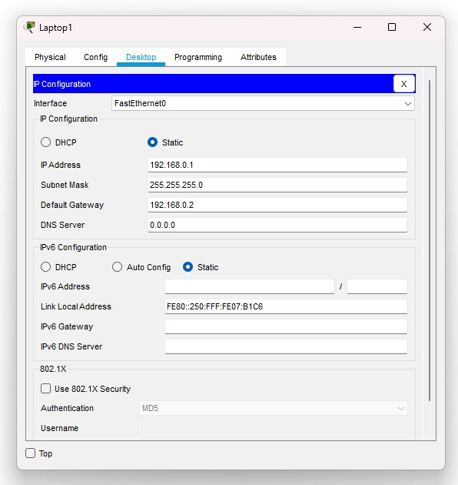

## Router 0

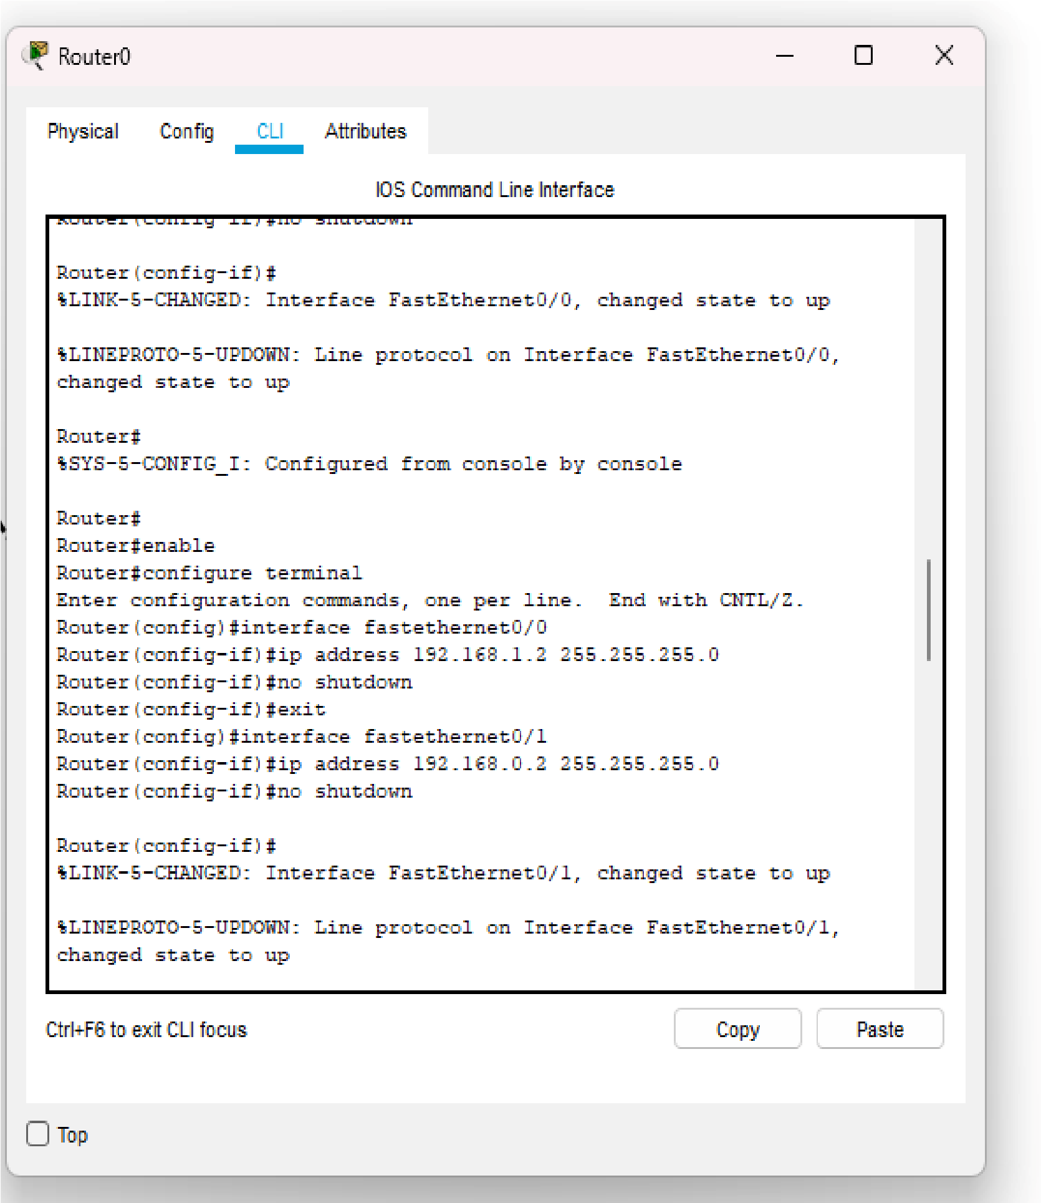

## Command Prompt

Laptop 0

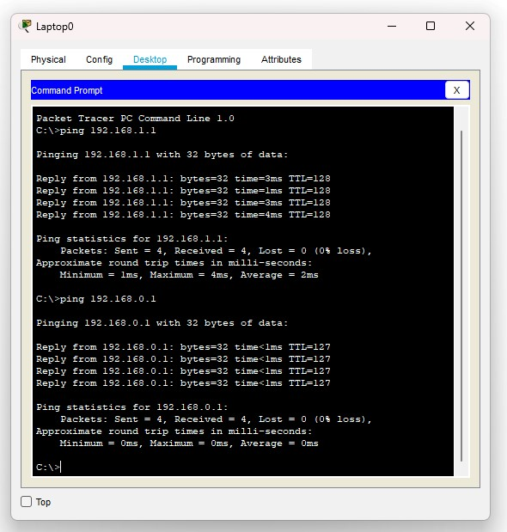

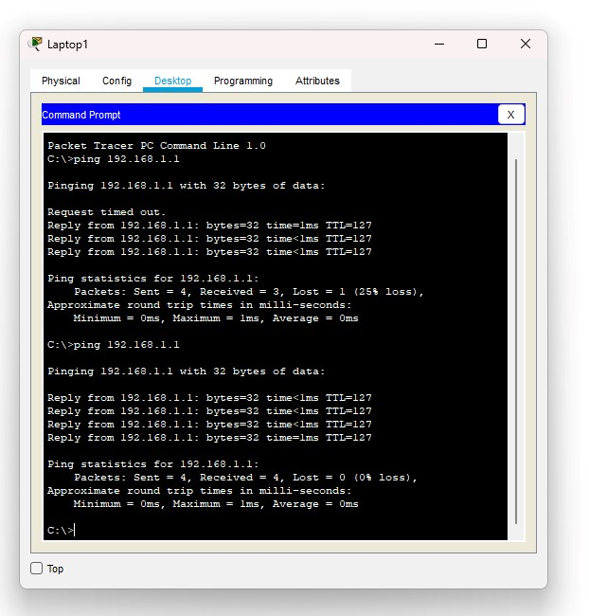

Laptop 1

1. **Perform an initial Router configuration:**
2. **Add a Router to the Network**
3. **Access the Router CLI**
4. **Enter Privileged EXEC Mode**
5. **Enter Global Configuration Mode**
6. **Set a Hostname**
7. **Configure an Interface**
8. **Verify configuration:**

**Check ip configuration, routing table, check saved configuration**

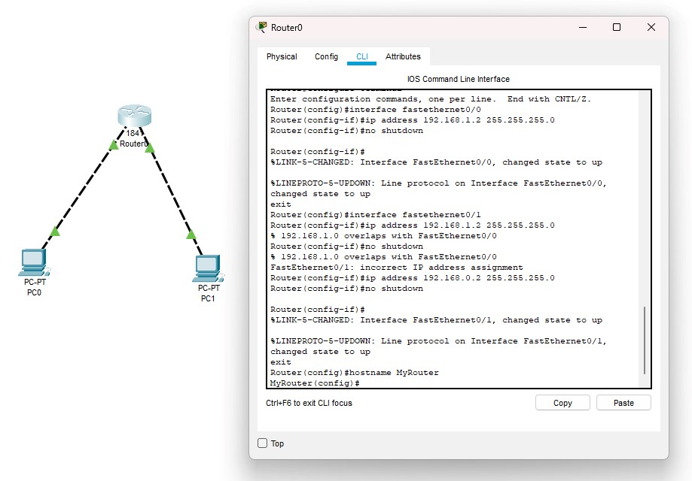

**PC 1**

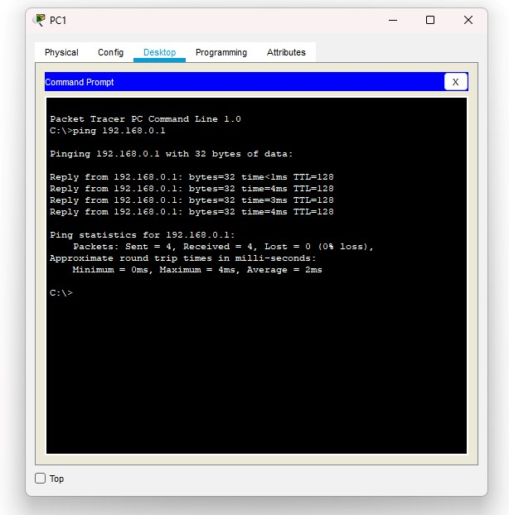

**PC0**

